

**ATLANTA RAP STAR HUNXHO RELEASES NEW SONG “COME OVER” FEATURING 2 CHAINZ**

**LISTEN** [**HERE**](https://hunxho.lnk.to/ComeOver)

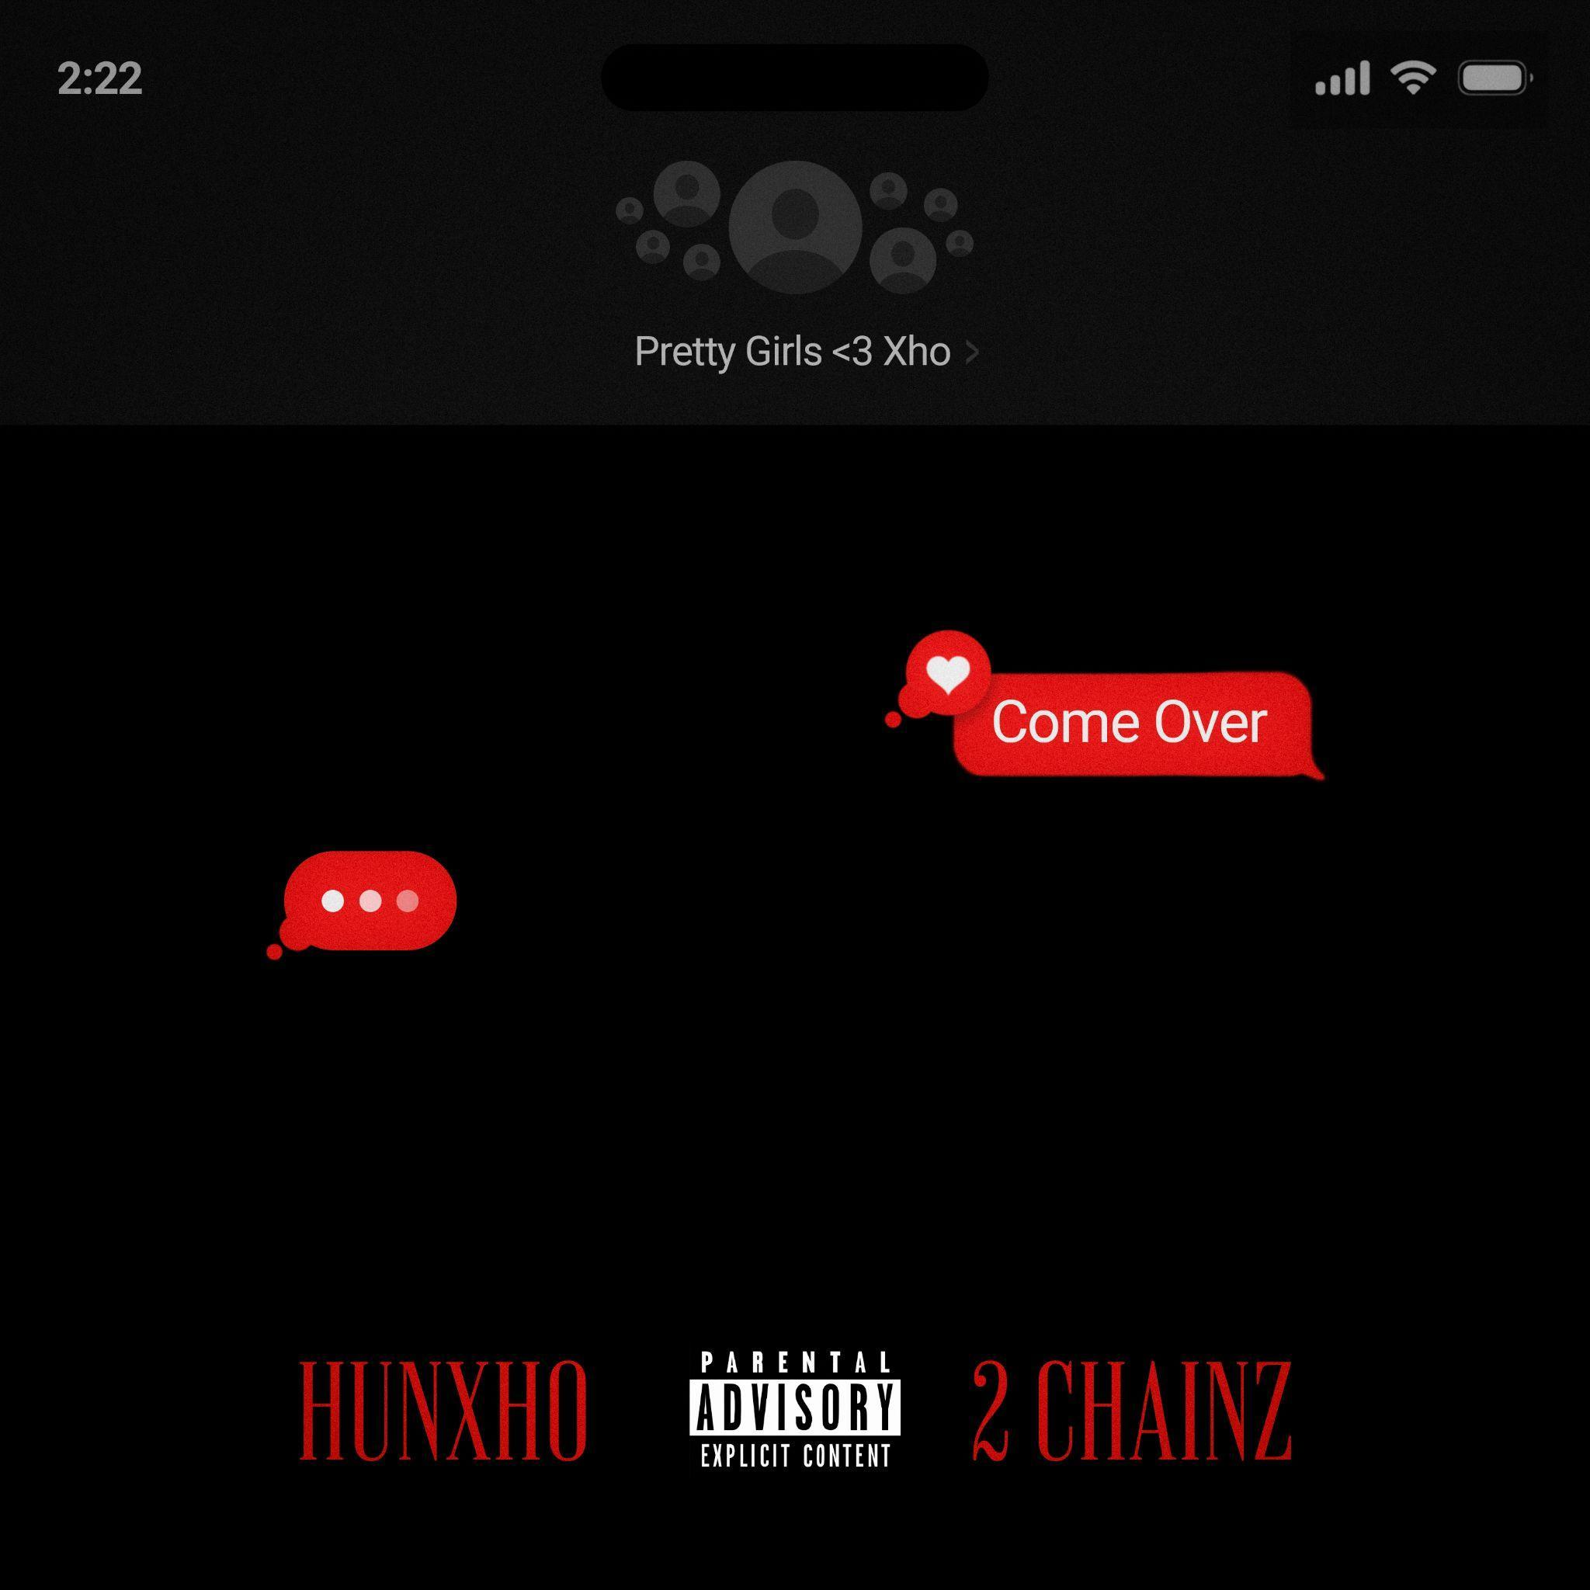

[**DOWNLOAD HI-RES ARTWORK HERE**](https://warnermusicgroup.box.com/s/tbi9anw8qce4uk7vw5reucsc6tsn6enc)

+ MUCH-ANTICIPATED NEW PROJECT COMING SOON

+ SELLING OUT DATES NATIONWIDE ON UPCOMING

*“ONE NIGHT ONLY”* NORTH AMERICAN TOUR

**(May 3, 2024 – New York, NY)** – On the verge of superstardom with a nearly sold-out tour and acclaimed records bubbling up, rising East Atlanta rapper **HUNXHO** unveils a new single entitled **“Come Over”** featuring **2 Chainz** out today via **300 Entertainment**. It increases anticipation for the arrival of his anxiously awaited forthcoming album—coming soon. Listen [**HERE**](https://hunxho.lnk.to/ComeOver).

The **Mike WiLL Made-It** produced track layers glitchy synths over a handclap-driven groove. Atlanta icon **2 Chainz** blesses the beat with his smooth signature flow. Meanwhile, **HUNXHO** carries the hypnotic hook with confidence and charisma as he says, *“I get you what you need, girl just let me show you*.” The song ultimately unites two eras of Atlanta hip-hop on one future-facing anthem.

It arrives on the heels of **“Closer To Over**.**”** Beyond posting up over 3 million and counting total streams, it attracted acclaim.[*XXL*](https://www.xxlmag.com/key-glock-future-hunxho-best-new-hip-hop-songs/) named it one of *“The 13 Best New Hip-Hop Songs This Week*.” Plus, **HUNXHO** just rolled through ***Genius*** for a powerhouse **Open Mic** performance of **“By Tomorrow**.**”** Watch [**HERE**](https://www.youtube.com/watch?v=ehn-qXgq71g).

Canvasing the country, he has already ***sold out ten dates*** in major cities—**Atlanta**, **NewYork**, **Chicago**, **Los** **Angeles**, **Dallas**, **Houston**, **Detroit**, **Raleigh**, **Norfolk**, and **Charlotte**—on his upcoming **“One Night Only” Tour**. Get tickets *(while they’re still available)*for the remaining dates [**HERE**](https://hunxhomusic.com/). Check out the full confirmed itinerary below.

**ABOUT HUNXHO**

**HUNXHO** slides through the vibes with grace, grit, and gusto.. Between the laidback rhymes and silky harmonies, charisma drives his seamless balance of provocative hip-hop and bedroom- ready R&B. With every move the Atlanta singer, rapper, and performer makes, you can hear, see, and feel his evolution loud and clear. Since 2017, he has risen into the spotlight on his own terms. Leaving behind the street life, he turned to music and locked into a prolific groove. He shined on the likes of **Street Poet**, **Street Poet 2**, and **Street Poetry**. Signing to **300** **Entertainment**, he landed a major hit with breakthrough record **“Let’s Get It (Remix)”** [feat. **21 Savage**]. He kicked off 2023 with **Humble As Ever**. The latter yielded the fan favorite “**Highly Performing**,” cracking 8﻿.3 million YouTube views. On its heels, he ignited his full-length debut album, **22**, highlighted by the viral and quotable “**48 Laws Of Power**.” **Lil** **Baby** personally tapped him as support on the sold out **I.O.U. Tour**, canvasing arenas and amphitheaters throughout North America. Meanwhile, he capped off a breakout year with the R&B-leaning ***For*** ***Her***. It notably marked his first entry on the **Billboard** **200**, while “**Yes**,” “**7 AM**,” and “**By Tomorrow**” gained major traction on streaming platforms. The centerpiece single “**Your Friends**” also piled up  65 million streams to date. Beyond looks from **UPROXX**, **Lyrical Lemonade**, **Billboard** and more, **INKED** chronicled how “HUNXHO has come so far in the past five years.” With more music, a sold-out headlining show in Atlanta, and touring on the horizon in 2024 he’s on the verge of superstardom.

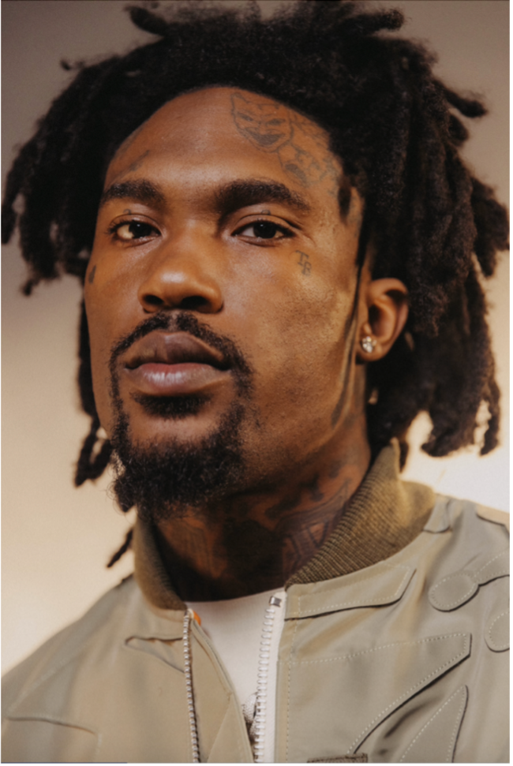

​​[**DOWNLOAD HI-RES PHOTO HERE**](https://warnermusicgroup.box.com/s/1nl2i31hby4so2cm60f9a8qzf3wu05az) (Photo Credit: Same Balaban)

| **CONNECT WITH HUNXHO:**  Instagram TikTok Twitter YouTube |
| --- |

**For More Information On Hunxho Contact:**

300 Entertainment | Publicity

Janelle Gibbs **| janelle.gibbs@300elektra.com**