**NGEEYL RELEASES NEW SINGLE**

**“TRIPLE KROSS KING”**

**Debut Album *SSETELIAN* Out December 15**

**Executive Produced by Lil Uzi Vert**

**[WATCH](https://youtu.be/0QKD3d5JYDQ?si=OhNx_VcuYs9koOZZ) |** [**LISTEN**](https://ngeeyl.lnk.to/TripleKrossKing)

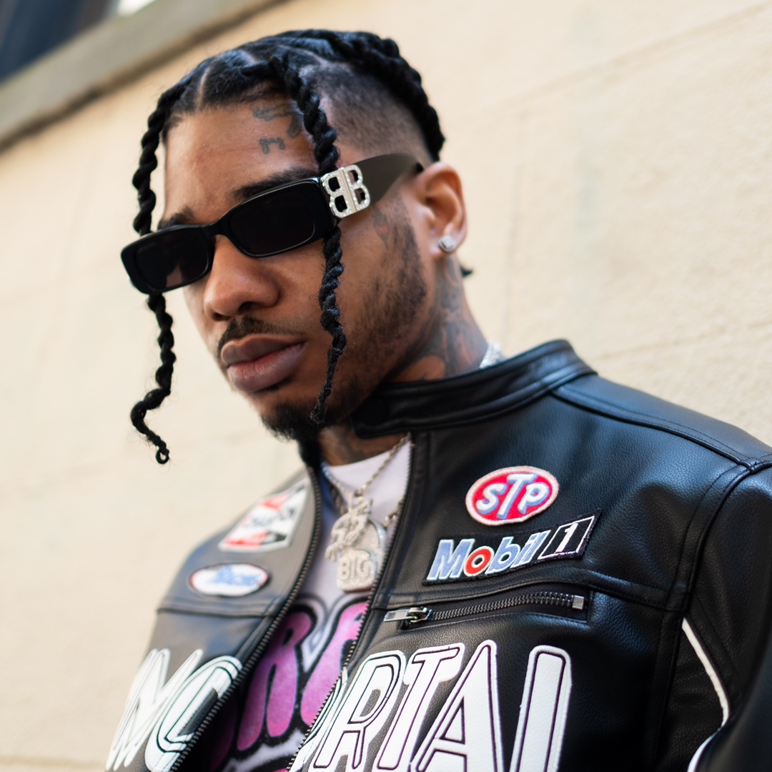

"NGeeYL is a rapper whose name you need to know." – **NYLON**

"NGeeYL gained the attention of Uzi with the release of his mixtape Hiatus, leading Uzi to shoutout him out on Instagram calling NGee his 'favorite rapper'" – **REVOLT**

"For a rapper who’s very early in his career, it’s impressive to see the recognition he has received and the upward trajectory he’s on." – **EARMILK**

Armed with high-profile co-signs and a fast-talking flow, South Carolina's NGeeYL stands on business with “Triple Kross King,” his new single from his forthcoming debut album *SSETELIAN*, out December 15th. NGeeYL continues to push boundaries and redefine the game with his raw and unfiltered voice. "Triple Kross King" demonstrates his unwavering commitment to his craft with heavy 808s, loud horns and eerily haunting elements that hook you in.

NGeeYL first started buzzing in 2019, building a following in the South and attracting praise from the likes of 21 Savage, Playboi Carti, and Young Nudy. He made his most impactful connection after releasing his mixtape *Hiatus*, catching the attention of Lil Uzi Vert, who called NGee his "favorite rapper." NGee and Uzi have been close ever since, with the superstar rapper making appearances in NGee's music videos (including the recent video for the F1LTHY-produced "Showtime") and collaborating with him on the fiery single "Off-White" (11.5 million total streams). The two rappers' fruitful creative partnership continues this year with the upcoming *SSETELIAN*, executive produced by Lil Uzi Vert himself.

[**STREAM NGEEYL “TRIPLE KROSS KING” HERE**](https://ngeeyl.lnk.to/TripleKrossKing)

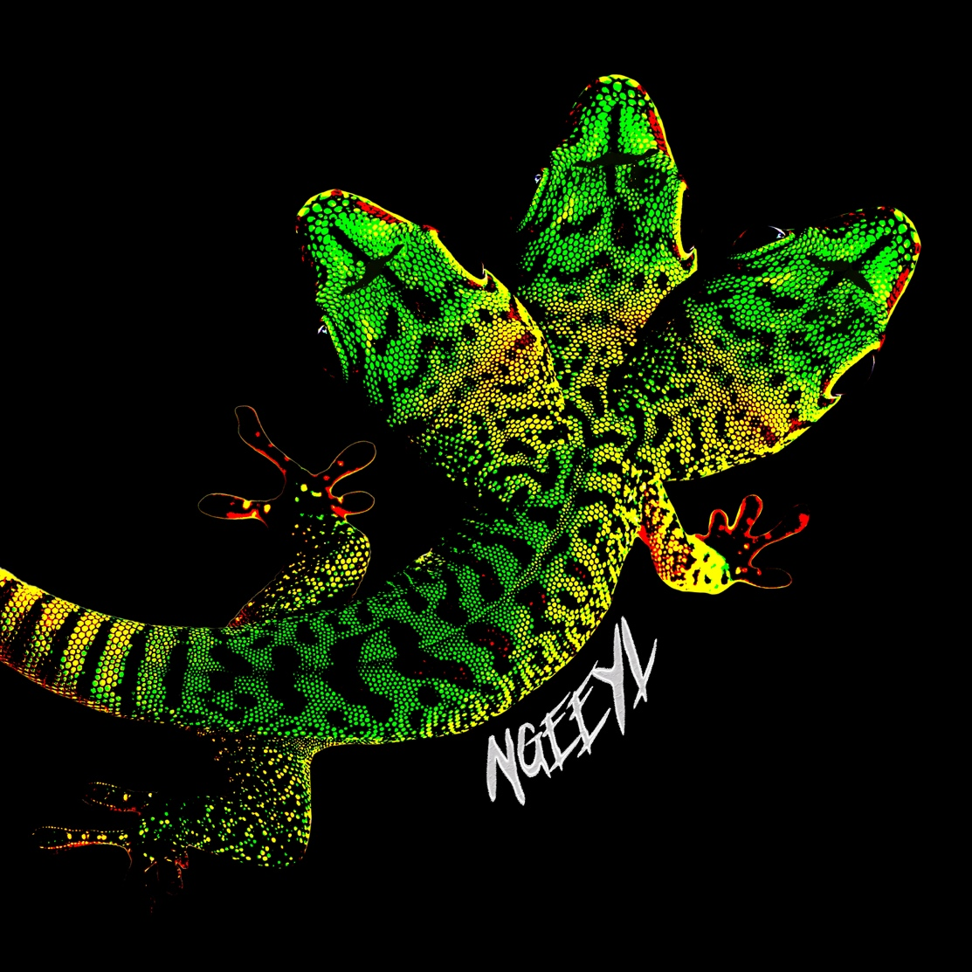

**ABOUT NGEEYL**:

Hailing from Spartanburg, SC, NGeeYL (pronounced “en-gee-why-el”), has turned to an old passion, rapping, to build a new identity. Gaining traction in his city from his hard-hitting and honest freestyles, he lives by the mantra to never water down the truth. His often-sedated flow and trap anthems have gained the attention of the likes of Lil Uzi, 21 Savage and Playboi Carti, as well as elite athletes across the nation including Zion Williamson, Deandre Hopkins, JJ Arcega, and more. In 2019, Ngee released his mixtape Hiatus, which featured fan favorite songs “Lullaby” ft. Young Nudy and “Lick” ft. Vale. The release of the mixtape earned him cosigns from Lil Uzi Vert (who would later become a close collaborator), 21 Savage, Playboi Carti and more. NGee’s most recent project *Live Ammo* was released in 2020, featuring notable tracks like “Kawasaki” ft. Lil Keed and “Sweep”, produced by fellow South Carolina native and GRAMMY nominated producer Jetsonmade. Last summer, he released his single “Off-White” with Lil Uzi Vert which serves as the first release from his forthcoming project *SSETILIAN*, executive produced by Uzi.

**CONNECT WITH NGEEYL:**

[Instagram](https://www.instagram.com/ngeeyl/?hl=en) | [TikTok](https://www.tiktok.com/@ngeeyl) | [YouTube](https://www.youtube.com/@NGeeYL) | [Twitter](https://twitter.com/bigbagLegend)

**FOR MEDIA INQUIRIES:**

Michael Adams | [michael.adams@threehundred.biz](mailto:michael.adams@threehundred.biz)