View this email in your browser

SHY GLIZZY’S RELEASES NEW SINGLE “SLIME U OUT” FEATURING 21 SAVAGE
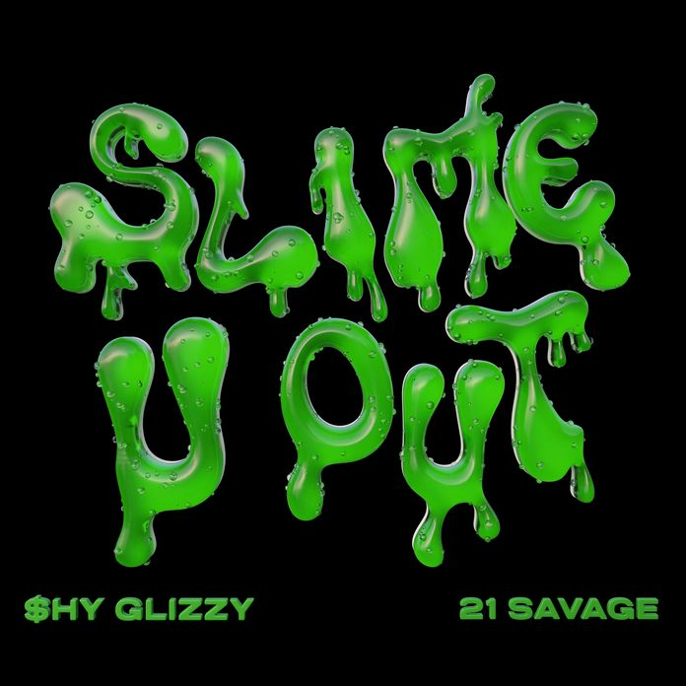
ANXIOUSLY AWAITED NEW ALBUM DUE IN 2023
LISTEN HERE!

(December 9, 2022 – New York, NY) – Multiplatinum GRAMMY® Award-nominated Washington, D.C. rapper and Glizzy Gang Founder Shy Glizzy unleashes a new single entitled “Slime U Out” [feat. 21 Savage] today via Glizzy Gang/300 Entertainment. This marks as the very first collaboration between these two.
“Slime U Out” drips out of the gate on shaky 808s and a punchy bass line, clearing the way for Shy Glizzy’s sharp, yet sinewy flow. Meanwhile, he confesses, “I got tunnel vision,” assuring an unbreakable grind for this next season. Of course, 21 Savage blesses the track with raucous and raw bars, highlighting his instantly recognizable cadence.
Shy Glizzy leans into the hallmarks of his now-classic style with a renewed sense of fire. Returning to his roots on his next album set for 2023.
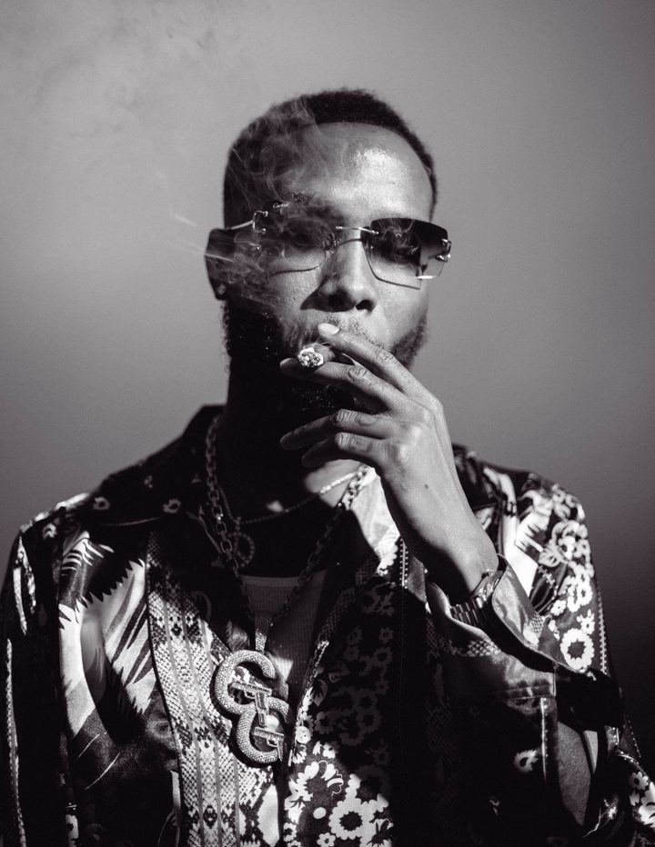
Recently, he earned a platinum plaque for his enduring banger “White Girl.” Of this milestone, TMZ proclaimed, “Proud D.C. rapper Shy Glizzy is living proof hard work pays off in the rap game … his 2014 jam ‘White Girl’ was certified platinum by the RIAA this week, a feat he accomplished from his own hustle and grind!!!” Taking a victory lap, he served up the music video for “White Girl” in celebration.
Of course, the track originally adorned his breakout 2014 mixtape, Young Jefe, which introduced his fan favorite series of the same name.
It also continues a prolific streak. He recently dropped “MMY Freestyle” and “Underrated.” He shot the eye-catching video for the latter in Dubai. Moreover, HotNewHipHop hailed “Underrated” as “airy and chilled-out,” and REVOLT plugged the video, “He spends the day cruising the desert in his luxury red whip before heading off to the local markets at night.”
Pushing forward without apology, Shy Glizzy consistently proves the real is back as he prepares more music for 2023.
Shy Glizzy has redefined, reignited, and reupped the DMV as a stronghold for hip-hop. Along the way, he has gathered over 1 billion streams and shined on the gold-certified “Do You Understand” [feat. Tory Lanez & Gunna] and the platinum-certified “White Girl.” He broke through into the mainstream in a big way with his appearance on Goldlink’s 6x-platinum “Crew” [feat. Brent Faiyaz & Shy Glizzy], earning a GRAMMY® Award nod in the process. Beyond widespread praise from Pitchfork, The FADER, The Washington Post, and more, he received a coveted cosign from Beyoncé who famously bopped along to “Awwsome” at Global Citizen Festival. Not to mention, he also heads up his own Glizzy Gang label as C.E.O. He not only remains a pillar of the DMV, but the culture at large as he kicks off his next era in 2023.
Copyright (C) 2023 300 Entertainment. All rights reserved.
You are receiving this email because you opted in via our website.
Our mailing address is:
300 Entertainment
112 Madison Ave
4th Floor
New York, NY 10016-7416
Add us to your address book
Want to change how you receive these emails?
You can update your preferences or unsubscribe

