
WANMOR TEAM UP WITH STEVIE WONDER FOR UNFORGETTABLE PERFORMANCE OF “THE WAY YOU DO THE THINGS YOU DO” BY THE TEMPTATIONS AT THE 65th ANNUAL GRAMMY® AWARDS


FAST RISING GROUP MADE THEIR DEBUT ON MARY J. BLIGE’S LABEL,

BEAUTIFUL LIFE PRODUCTIONS

SELF-TITLED DEBUT WANMOR EP COMING SOON

LISTEN TO “EVERY PRETTY GIRL IN THE CITY” & “MINE” OUT NOW!

(NEW YORK, NY - February 6, 2023) – Making their GRAMMY® Awards debut and appearing during the most powerful moments of last night’s GRAMMY® Awards, fast rising brotherly R&B group WanMor joined forces with none other than the legendary Stevie Wonder to perform “The Way You Do The Things You Do”, originally by The Temptations to honor Berry Gordy and Smokey Robinson for MusiCares Persons of the Year.

Representing a passing-of-the-torch from one generation to the next, WanMor’s performance stands out as a superstar-making turn. They paid homage to The Temptations alongside one of the most influential artists in history. This only hints at a massive year for the group though.
They started the evening and graced the red carpet for a nonstop series of interviews. During this media blitz, they broke the news of their forthcoming self-titled debut, WanMor EP.
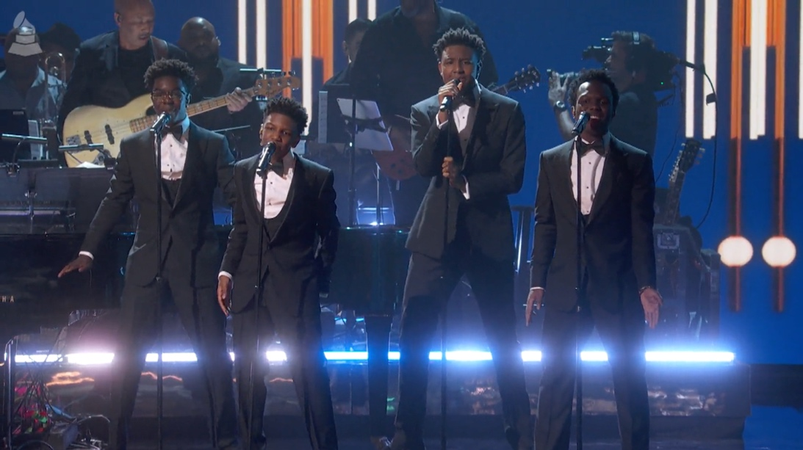
Recently, the group shared the single “Mine” and “Every Pretty Girl in the City” Right out of the gate, it earned widespread critical acclaim. Last year, WanMor’s two-month Every Pretty Girl in the City Tour announced their arrival as a phenomenon. Among many highlights, they turned up at The American Dream Mall for a pop-up performance, igniting the crowd into a fervent frenzy. They impressively delivered pop-up performances at elementary, middle and high schools up and down the coast, rolling through Atlanta, Baltimore, New York, Florida, North, and South Carolina, and beyond. Making headlines, they’ve also recently appeared on Good Day Atlantaand News4Jax Morning Show as part of their fall promo tour.

About WanMor
WanMor, South Jersey’s latest R&B sensation, is a boy group composed of real-life brothers, Big Boy, Chulo, Tyvas, and Rocco. Ranging in age from 12-18, the boys have spent the last five years honing their stunning textures and rich sound while doing large-scale performances across the country, including venues such as Madison Square Garden and the STAPLES Center. The dynamic four-piece has also appeared on America’s Most Musical Family, and guest starred on a special episode of Sesame Street, “The Not-Too-Late Show with Elmo,” and Little Big Shots. They are featured on five tracks from Lil Uzi Vert’s platinum album Eternal Atake and most recently Hunxho's "Heartless". They are the first act signed to Mary J. Blige’s 300 Entertainment imprint, Beautiful Life Productions, Inc.

