View this email in your browser


OMB PEEZY RELEASES

NEW SINGLE + MUSIC VIDEO

“650” FT. BABY MONEY

-WATCH HERE-
+OMB Peezy Links Up With Quality Control Signee Baby Money For His Latest Release

DOWNLOAD SINGLE ART + PRESS IMAGES HERE (PC: Jason Goodrich)
FRIDAY - APRIL 22, 2022 – Today, rapper OMB Peezy releases his new single “650” ft. Baby Money via 300 Entertainment. Detroit and Alabama come together for a new street anthem accompanied by an explosive video. The track is undeniably bold and high-energy, with Peezy and Baby Money going bar for bar in the visual and showcasing their lavish lifestyles.
About the track, Peezy says “650 is a song to show my fans that I’m still having fun with life . From cars to jewelry. And I rapped over a Detroit beat to show how versatile I am. And it was only right to get Baby Money on the song. We were already familiar with each other from recording at the same studio in California."
The release of “650” jumpstarts a new era for Peezy, coming on the heels of an eventful year for the rapper, which included an appearance on King Von’s 2022 album What It Means To Be King with “Get It Done”. Last year, Peezy released the collaborative In the Meantime II mixtape with notable producer, DrumDummie. The tape features appearances from T.k. Kravitz, Omertà, Mistah Cain, and T.I. Peezy has plenty more of his story to tell and he is gearing up for new music, feeding fans one incendiary track after another.
LISTEN TO “650” BY OMB PEEZY FT. BABY MONEY:
https://ombpeezy.ffm.to/650_
WATCH “650” BY OMB PEEZY FT. BABY MONEY MUSIC VIDEO:
https://www.youtube.com/watch?v=YqsWJjUUDaY
EMBED “650” BY OMB PEEZY FT. BABY MONEY MUSIC VIDEO:
<iframe width="560" height="315" src="https://www.youtube.com/embed/YqsWJjUUDaY" title="YouTube video player" frameborder="0" allow="accelerometer; autoplay; clipboard-write; encrypted-media; gyroscope; picture-in-picture" allowfullscreen></iframe>

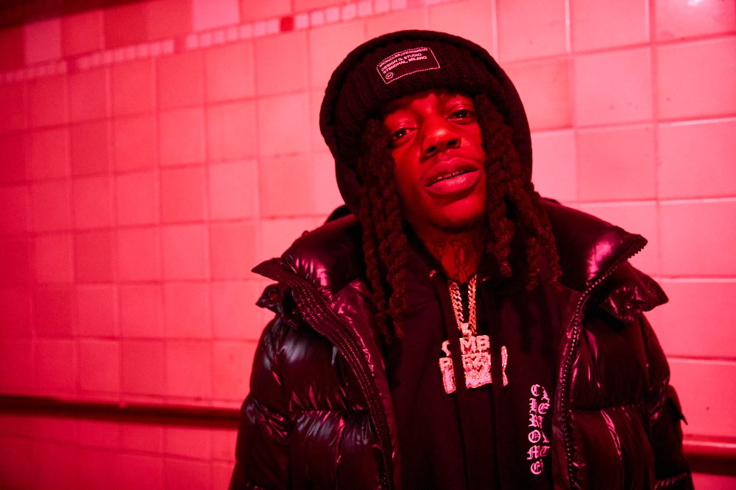
DOWNLOAD SINGLE ART + PRESS IMAGES HERE (PC: Jason Goodrich)
For Press Inquires Contact: Deneil Mullings (deneil@threehundred.biz)

