

MARY J. BLIGE RELEASES NEW ALBUM
‘GOOD MORNING GORGEOUS’
Blige dropped new album today ahead of her historic performance this Sunday during the Pepsi Super Bowl LVI Halftime Show
STREAM ALBUM HERE
WATCH “RENT MONEY” HERE
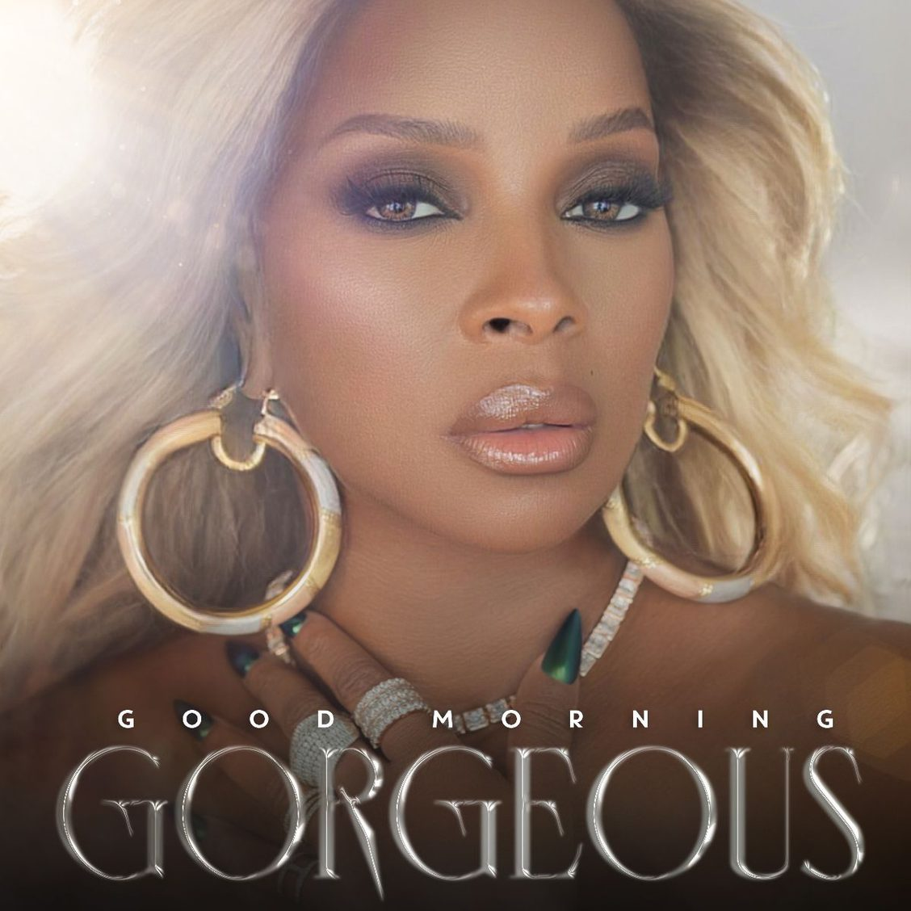
ALBUM ARTWORK
PRESS IMAGE
(New York, NY – Friday, February 11, 2022) Today, 9x Grammy award winning and 2x Oscar nominated artist, producer, and actress Mary J. Blige released her new studio album, ‘Good Morning Gorgeous,’ that can be streamed or purchased now HERE. The 13-song track list includes collaborations with Anderson .Paak, Usher, DJ Khaled, Dave East, and Fivio Foreign. Blige also dropped the video today for “Rent Money” (featuring Dave East) and directed by Eif Rivera that can be viewed HERE.
The album follows her leading role performance as Monet on Starz's ‘Power Book II: Ghost’ that won her the NAACP Image Award for ‘Outstanding Supporting Actress in a Drama Series’ in 2021 and the nomination once again in 2022, among other honors. The release of ‘Good Morning Gorgeous’ leads into a historic performance this Sunday, February 13th, at the Pepsi Super Bowl LVI Halftime Show at SoFi Stadium in Inglewood, CA alongside Dr. Dre, Eminem, Snoop Dogg and Kendrick Lamar.
Blige launched the album campaign with single and video “Good Morning Gorgeous” along with “Amazing” (featuring DJ Khaled). Since its release, “Good Morning Gorgeous” has been used by fans on TikTok to express and promote self-love, self-empowerment, and self-care with over 40,000 total creates, and is growing 40% every week. A compilation of select videos can be viewed HERE. The song is also climbing the radio charts, having entered the Top 30 at Urban and is poised for #1 at R&B.
All new music is released through Blige’s own banner, Mary Jane Productions, and in partnership with 300 Entertainment.
‘Good Morning Gorgeous’ Track List
1. No Idea
2 Love Will Never
3. Here With Me (feat. Anderson .Paak)
4. Rent Money (feat. Dave East)
5. Amazing (feat. DJ Khaled)
6. GMG interlude
7. Good Morning Gorgeous
8. Come See About Me
9. On Top (feat. Fivio Foreign)
10. Love Without The Heartbreak
11. Failing in Love
12. Enough
13. Need Love (feat. Usher)
For more information, please visit https://www.maryjblige.com/.
###
ABOUT MARY J. BLIGE
Iconic Grammy Award-winning singer, songwriter, Oscar-nominated actress, producer and philanthropist, Mary J. Blige is a figure of inspiration, transformation and empowerment making her one of the defining voices of the contemporary music era. With a track record of eight multi-platinum albums, nine Grammy Awards (plus a staggering 32 nominations), two Academy Award nominations, two Golden Globe nominations, and a SAG nomination, among many other accolades, Blige has cemented herself as a global superstar. And in the ensuing years, the singer/songwriter has attracted an intensely loyal fan base—responsible for propelling worldwide sales of more than 50 million albums.
Influenced at an early age by the music of Aretha Franklin, Chaka Khan and Gladys Knight, Blige brought her own gritty, urban-rooted style—fusing hip-hop, soul and honest, frank lyrics—to the forefront on her 1992 debut album What’s the 411? The multi-platinum set, executive produced by Sean “Diddy” Combs, quickly spun off several hits, including two No. R&B No. 1s: You Remind Me and Real Love. Blige helped redefine R&B and began forging a unique niche for herself on the more personal second album, 1994’s My Life. She is loved for her passionate, chart-topping hits like “Be Without You”, “No More Drama” and “Family Affair” all of which have made her a force in music.
Each subsequent album reads like a chapter from an autobiography: Share My World (1997), Mary (1999), No More Drama (2001), Love & Life (2003), the multiple Grammy-winning and hit-spewing The Breakthrough (2005), Growing Pains (2007), Stronger with Each Tear (2009), My Life II... The Journey Continues (2011), A Mary Christmas (2013) and The London Sessions (2014). Along the way, she’s lined up a string of hit singles, including Not Gon’ Cry, Love Is All We Need, Seven Days, All That I Can Say, Family Affair and Just Fine.
Blige released her 14th studio album Strength of a Woman in 2017. The first single, “Thick of It,” held the number 1 spot on the Urban AC Chart for 16 consecutive weeks after its release in November. Blige also scored her latest #1 single off this album with “U + Me (Love Lesson).”
In the summer of 2019, Blige was honored with the BET Lifetime Achievement award, and completed a U.S Summer tour with New York rapper Nas.
On the acting side, Blige starred as Florence Jackson in the 2017 Netflix breakout film Mudbound, to which she received critical acclaim including two Academy Award nominations for Best Support Actress and Best Original Song. She starred in the Netflix series “The Umbrella Academy,” which premiered on the platform in February 2019.
In April 2020, Blige voiced “Queen Essence” in Dreamworks’ TROLLS WORLD TOUR movie, and starred in Paramount’s Body Cam, alongside Nat Wolff, that was released digitally in May 2020. Blige dropped a new single entitled “Can’t Be Life,” an original song for Body Cam that speaks candidly to the current times and is featured over the end credits of the film. Blige is currently starring in STARZ’s POWER BOOK II: GHOST, a new television series inspired by the original show, POWER, that premiered in September 2020 and recently wrapped its second season on the network. The show has been renewed for a third season.
On the producing side, Blige launched her production company, Blue Butterfly, and signed a first-look TV deal with Lionsgate. Blige most recently Executive Produced Lifetime’s The Clark Sisters: First Ladies of Gospel. The biopic marked the highest-rated original movie for Lifetime since 2016.
Blige has also entered the fashion and beauty realm with her jewelry line “Sister Love” with long-time friend Simone I. Smith and her “Love Me” lipstick line with MAC Cosmetics. Most recently, she launched her own wine collection, Sun Goddess Wines, in collaboration with the internationally prestigious Fantinel Winery. The collection currently includes two wines that are now available nationwide, an Italian Pinot Grigio Ramato and an Italian Sauvignon Blanc.
In 2020, Blige wrote and performed a new song for the celebrated documentary Belly of the Beast entitled “See What You’ve Done.” The documentary uncovers illegal sterilizations in women’s prisons in the Department of Corrections in California and was filmed over a period of seven years. Blige also recently starred as Dinah Washington in the Aretha Franklin biopic, Respect, alongside Jennifer Hudson, which was released in August 2020.
Most recently, Blige worked with Oscar-winning filmmaker Vanessa Roth and Amazon on the documentary “Mary J Blige's My Life” celebrating the 25th anniversary of her famed album My Life. Blige is not only the subject of the documentary, where she reflects on her nearly 30-year career within the music industry, but also serves as an Executive Producer through her own production company Blue Butterfly. She also wrote an original song for the documentary, Hourglass. The documentary was released via Amazon Prime Video on June 25, 2021.
ABOUT 300 ENTERTAINMENT
Since launching in 2012, 300 Entertainment has groomed, grown, and galvanized a new generation of superstars across hip-hop, rock, pop, electronic, and alternative. 300’s development-focused and digital-centric disruption has quietly elevated the brand to the cutting edge of both music and culture. Among many achievements, roster acts have garnered a total of 4 GRAMMY® Awards, 13 GRAMMY® Award nominations, a Shorty Award, nearly 200 RIAA gold, platinum, multi-platinum, and diamond-certified singles, NAACP Award, American Music Award, BET Award nominations and wins. Led by CEO and Co-founder Kevin Liles, the label has positioned itself at the forefront of streaming. Its revenue is comprised of 95% streaming and the label has garnered over 75 billion cumulative streams to date. The company has also been named one of Inc. Magazine's Best Workplaces, and was included on Fast Company’s Brands That Matter list as well as Fast Company’s Best Workplaces for Innovators list (Small Company category). 300 has also consistently championed social justice and social responsibility. In recent years, the company implemented the 300 Entertainment Social Justice League, several large-scale donations, and a forthcoming 501c3 for the company that seeks restorative justice for families of police killings.
300 Entertainment’s talent includes Mary J. Blige, Megan Thee Stallion, Young Thug, Gunna, Lil Keed, Tee Grizzley, Famous Dex, Highly Suspect, Fetty Wap, Drax Project, YNW Melly, Bailey Bryan, and more. 300 Entertainment has since launched ventures and partnerships such as Young Thug’s YSL, Shy Glizzy’s Glizzy Gang, and RGF Island.
Media Contacts for Mary J. Blige:
The Lede Company
Amanda Silverman
Amanda.Silverman@LedeCompany.com
Dvora Englefield
Dvora.Englefield@LedeCompany.com
Amanda Della Ragione
Amanda.Dellaragione@ledecompany.com
Media Contact for 300 Entertainment:
Lily Golightly
lily@threehundred.biz

