

$NOT Shares New Album Ethereal
Out Now via 300 Ent
+ With Creative Direction from A$AP Rocky & AWGE, Plus Appearances From Trippie Redd, Juicy J, Kevin Abstract, Joey Bada$$ & More, Ethereal is a Self-Assured and Versatile Effort From One of Rap's Most Exciting Rising Stars
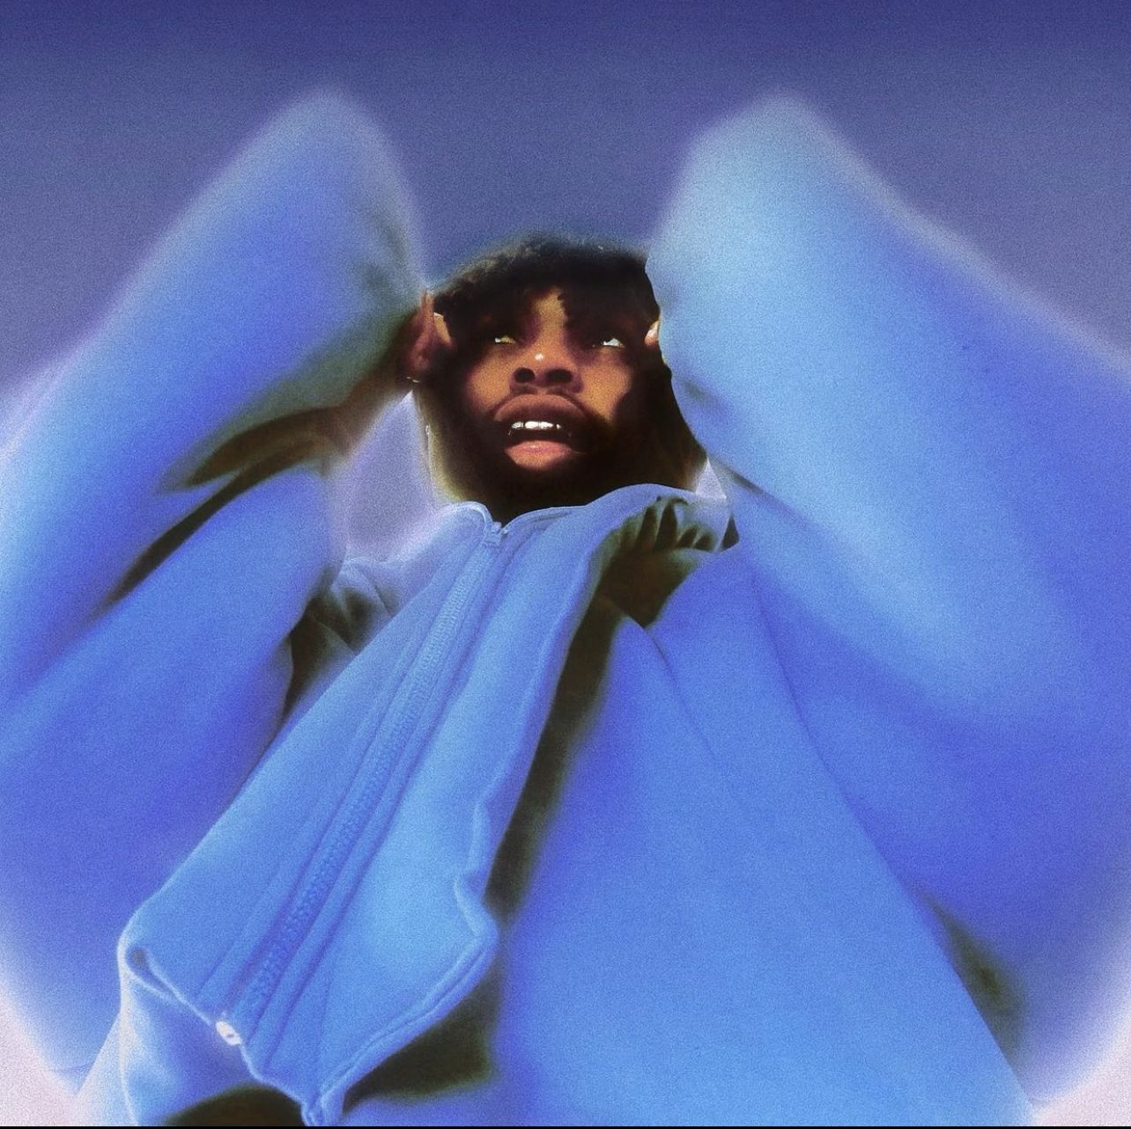
Download Cover Art and Press Photo Here

February 11, 2022 – With wide-ranging tastes and talent to match, $NOT occupies a sonic universe that is entirely his own. Sharing a cohesive collection of immersive and otherworldly rap songs, the 24-year-old artist shares Ethereal, his most accomplished full-length to date. An expansive effort that alternates soul-searching ballads with amped, pugilistic anthems like the recent single "Doja" ft. A$AP Rocky (the video for which reached YouTube's trending chart after the audio generated over 10 million combined streams in less than 1 week), Ethereal finds the West Palm Beach, FL-based artist reconciling his life as a rising rap star with the inner demons he battles every day.
Aided by creative direction from AWGE, $NOT indulges in his most adventurous artistic ideas on this album, trying his hand at every style under the sun. He recruits Joey Bada$$ for "How U Feel," a traditionalist boom-bap workout, just minutes after teaming with Trippie Redd for the synth-heavy rager "ALONE" and trading verses with Juicy J in the lounge-accented Tennessee trap of "Halle Berry."
The follow-up to 2020's Beautiful Havoc, Ethereal marks a new era for the young artist–he sheds some (though not too much) of the misanthropy that animated his early hits like "GOSHA," and embraces an open and experimental attitude that's reflected by his awestruck expression on the album's cover. Featuring additional guest appearances from Kevin Abstract and Teddi Jones, Ethereal is available everywhere via 300 Ent.
“It’s called Ethereal because each song seems to belong to another world,” says $NOT.
Ethereal capitalizes on the momentum generated by $NOT's successful 2021, in which he made major moves that helped him grow his audience to more than 10 million monthly listeners on Spotify. He earned his first PLATINUM plaque and Billboard Hot 100 appearance for "Tell Em," racked up over 11 million YouTube views on "Whipski," a Cole Bennett-directed collaboration with Lil Skies, and notched additional collaborations with Kevin Abstract & slowthai, DJ Scheme & Fenix Flexin, and SSGKobe. $NOT showed off his live performance chops over the summer at festivals like Rolling Loud, Day N Vegas, Firefly, and Lyrical Lemonade's Summer Smash, and was recognized on the cover of publications like Miami New Times, VIPER Mag, KAZI, and PREME. In 2020, $NOT made his mark with two projects: Beautiful Havoc, home to singles like "Revenge" and "Mean" ft. Flo Milli, and - TRAGEDY +, home to the GOLD-certified hits "GOSHA" and "Moon & Stars" ft. Maggie Lindemann.
Along with Ethereal, $NOT releases a new line of merchandise, designed by Copes. Purchase the new merch, which includes multiple hoodie and t-shirt designs, at https://shop.snot.xyz/
With Ethereal on the way, $NOT looks likely to reach yet another level of artistry and stardom this year. Keep an eye on the young rapper as he continues to evolve into an icon on his own uncompromising terms.
Ethereal Tracklist:
1) My World (Intro)
2) Doja ft. A$AP Rocky
3) BLUE MOON ft. Teddi Jones
4) Go
5) 5AM
6) ALONE ft. Trippie Redd
7) BENZO
8) EYE EYE EYE ft. Kevin Abstract
9) Euphoric
10) Halle Berry ft. Juicy J
11) How U Feel ft. Joey Bada$$
12) Fighting Me
13) high IQ
14) Once Upon A Time (Outro)
STREAM ETHEREAL BY $NOT:
https://snot.ffm.to/ethereal

PRAISE FOR $NOT
"At a certain point, all these moments added up to one undeniable fact: $NOT is a legitimate star who makes music that will find its way to the ears of millions, no matter where it’s shared on the internet." - Complex
"He's well on his way to being one of the next independent rappers to make a mainstream splash... $NOT's got a very particular kind of charisma, and one single at a time, everything's clicking." - Pigeons & Planes
"Over the years, $not has evolved from an experimental ASMR-type artist to a distinctive lyricist who's destined to lead the new wave of the SoundCloud era." - Miami New Times (cover story)
"Beautiful Havoc presents a spectrum of ever-changing moods, reflecting the binary suggested by its title. The tone is mostly relaxed and casually charismatic, anchored by $NOT’s precise and direct delivery, but there’s a creeping negativity on the margins...There’s enough havoc in the world already—$NOT finds time in his music for more elegant things." - Pitchfork
"$NOT's 'Pressure' Reveals a Changing Tide in Hip Hop...His nonchalant flow and reserved style does not diminish his dark, heavy lyrics and straight-to-it delivery." - Teen Vogue

For Press Inquires Contact: Deneil Mullings (deneil@threehundred.biz)

